08th February 2017

**YOKOHAMA Italy Collaboration with Team Bassano in Classic Car Rally**

YOKOHAMA Italy and Team Bassano have renewed their partnership for the 8th edition of the Abarth A112 Trophy. The historical cars Championship is the most important in its class within Italy and boasts a long and well established tradition.

This year will mark forty years from the first edition which was won by the legendary Attilio Bettega in 1977.

On March 11th the new edition of the trophy will take place with YOKOHAMA as a technical partner and tyre supplier. With 6 Rally within the Championship, the classic cars taking part will face exciting routes and tracks which have been specifically designed for the cars in this category.

After the March debut in Tuscany, the A112 Abarth Trophy will continue its adventure in Trentino Alto Adige, Veneto, Lombardy and Emilia Romagna. The final Rally will be held in September on the Island of Elba.

All cars will be equipped with YOKOHAMA ADVAN A032 tyres.

"We are very happy to carry on supporting this adventure." – Stated Giuseppe Pezzaioli, Motorsport Manager for YOKOHAMA Italy - "Together with Team Bassano we have worked very well in these years and the historic car enthusiasts will once again be able to appreciate even more the superb performance and features of our YOKOHAMA tyres.

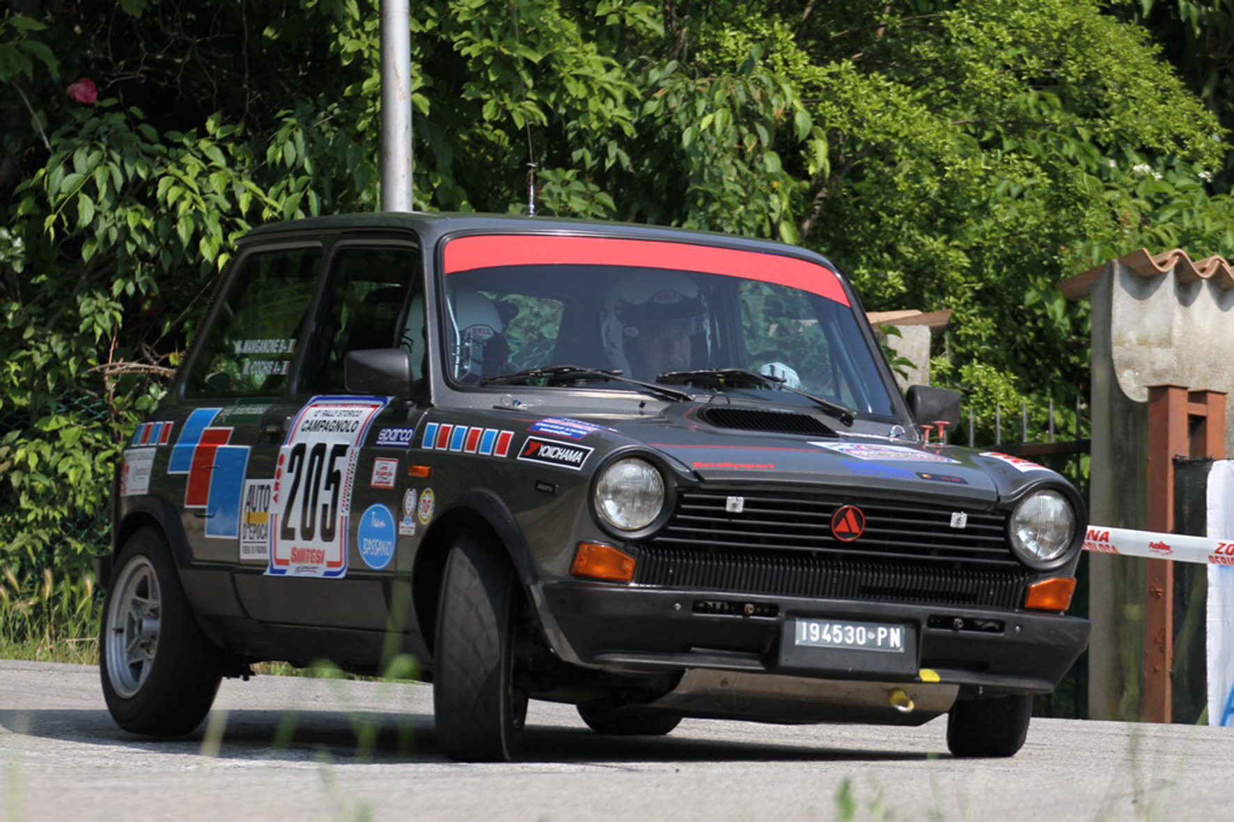

*Classic Car Rally Trophy-A112-Abath-Yokohama*